Introduction to Maus Guided Notes
Background
Art Spiegelman born in ______________________________________, Art Spiegelman is a ______________________________________.
Lived with his parents in ____________________________________________________________.
From 1966 to 1989 ________________________________________________________________
________________________________________________________________________________.
He has written many comix (underground comics), worked as a New Yorker staff artist and writer, and been a lecturer and teacher at various times in his career.
His work has been the subject of special museum and gallery exhibits both in the U.S. and abroad________________________________________________________________________.
Maus is a __________________________. (__________ ________________)
Art Spiegelman_________________________________________________, tells how he
_____________________________________________________________________________.
It tells the story of the father's _______________________ and ___________________. It is written in a _________________________, with various types of __________________ representing the
________________________________________________________________________________.
Characters

Visual Metaphor:_____________________________________________________________
___________________________________________________________________________
The _________ are represented by ________________.
The __________________ are represented by ________________.
The _____________________ are represented by ____________.
The _____________ are represented by _____________.
How to Read a Graphic Novel

A ______________ with images similar to a _______________________. Graphic novels are

_______________than an ordinary comic book and tend ______________________________________.
______________________________________________________
_____________________________________________________
______________________________________________________

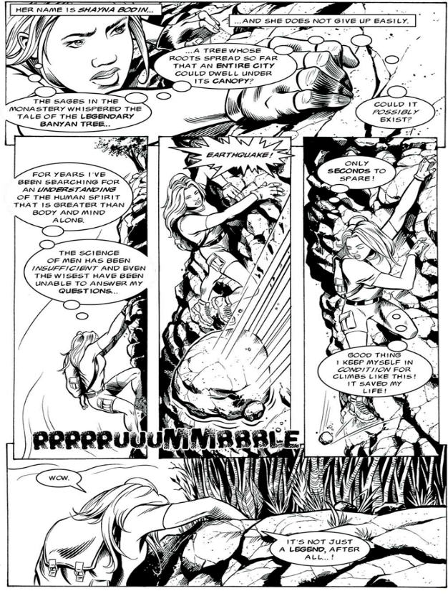
Panels-

Gutters-

Dialogue Balloons-

Thought Balloons-

Captions-

Sound Effects-

___________________________________________________________________________

___________________________________________________________________________

